GREEN NATIONAL MODEL HIGH SCHOOL ADILPUR
CLASS: ONE _{1st} _{TERM EXAMINATION 2025-26} _{SUBJECT: ENGLISH}
DATE: 14/10/2025 _{TIME ALLOWED 3 HOURS} MAX MARKS: 50

Seat No: ____________ Signature: ____________

Q:1 Write the Capital letters A to Z?
_________________________________________________________________________________________________________________________________________________________________
_________________________________________________________________________________________________________________________________________________________________
_________________________________________________________________________________________________________________________________________________________________
_________________________________________________________________________________________________________________________________________________________________

_________________________________________________________________________________________________________________________________________________________________
_________________________________________________________________________________________________________________________________________________________________
_________________________________________________________________________________________________________________________________________________________________
_________________________________________________________________________________________________________________________________________________________________

_________________________________________________________________________________________________________________________________________________________________
_________________________________________________________________________________________________________________________________________________________________
_________________________________________________________________________________________________________________________________________________________________
_________________________________________________________________________________________________________________________________________________________________

_________________________________________________________________________________________________________________________________________________________________
_________________________________________________________________________________________________________________________________________________________________
_________________________________________________________________________________________________________________________________________________________________
_________________________________________________________________________________________________________________________________________________________________

_________________________________________________________________________________________________________________________________________________________________
_________________________________________________________________________________________________________________________________________________________________
_________________________________________________________________________________________________________________________________________________________________
_________________________________________________________________________________________________________________________________________________________________

Q:2 Write the Small letters a to z?
_________________________________________________________________________________________________________________________________________________________________
_________________________________________________________________________________________________________________________________________________________________
_________________________________________________________________________________________________________________________________________________________________
_________________________________________________________________________________________________________________________________________________________________

_________________________________________________________________________________________________________________________________________________________________
_________________________________________________________________________________________________________________________________________________________________
_________________________________________________________________________________________________________________________________________________________________
_________________________________________________________________________________________________________________________________________________________________

_________________________________________________________________________________________________________________________________________________________________
_________________________________________________________________________________________________________________________________________________________________
_________________________________________________________________________________________________________________________________________________________________
_________________________________________________________________________________________________________________________________________________________________

_________________________________________________________________________________________________________________________________________________________________
_________________________________________________________________________________________________________________________________________________________________
_________________________________________________________________________________________________________________________________________________________________
_________________________________________________________________________________________________________________________________________________________________

_________________________________________________________________________________________________________________________________________________________________
_________________________________________________________________________________________________________________________________________________________________
_________________________________________________________________________________________________________________________________________________________________
_________________________________________________________________________________________________________________________________________________________________

Q:3 Write the consonant letter?
_________________________________________________________________________________________________________________________________________________________________
_________________________________________________________________________________________________________________________________________________________________
_________________________________________________________________________________________________________________________________________________________________
_________________________________________________________________________________________________________________________________________________________________

_________________________________________________________________________________________________________________________________________________________________
_________________________________________________________________________________________________________________________________________________________________
_________________________________________________________________________________________________________________________________________________________________
_________________________________________________________________________________________________________________________________________________________________

_________________________________________________________________________________________________________________________________________________________________
_________________________________________________________________________________________________________________________________________________________________
_________________________________________________________________________________________________________________________________________________________________
_________________________________________________________________________________________________________________________________________________________________

Q:4 Write Vowel letters?
_________________________________________________________________________________________________________________________________________________________________
_________________________________________________________________________________________________________________________________________________________________
_________________________________________________________________________________________________________________________________________________________________
_________________________________________________________________________________________________________________________________________________________________

Q:5 Write the spellings Apple to Egg?
_________________________________________________________________________________________________________________________________________________________________
_________________________________________________________________________________________________________________________________________________________________
_________________________________________________________________________________________________________________________________________________________________
_________________________________________________________________________________________________________________________________________________________________

_________________________________________________________________________________________________________________________________________________________________
_________________________________________________________________________________________________________________________________________________________________
_________________________________________________________________________________________________________________________________________________________________
_________________________________________________________________________________________________________________________________________________________________

_________________________________________________________________________________________________________________________________________________________________
_________________________________________________________________________________________________________________________________________________________________
_________________________________________________________________________________________________________________________________________________________________
_________________________________________________________________________________________________________________________________________________________________

Q:6 What is your name?
_________________________________________________________________________________________________________________________________________________________________
_________________________________________________________________________________________________________________________________________________________________
_________________________________________________________________________________________________________________________________________________________________
_________________________________________________________________________________________________________________________________________________________________

Q:7 What is your father's name?
_________________________________________________________________________________________________________________________________________________________________
_________________________________________________________________________________________________________________________________________________________________
_________________________________________________________________________________________________________________________________________________________________
_________________________________________________________________________________________________________________________________________________________________

Q:8 What is your caste?
_________________________________________________________________________________________________________________________________________________________________
_________________________________________________________________________________________________________________________________________________________________
_________________________________________________________________________________________________________________________________________________________________
_________________________________________________________________________________________________________________________________________________________________

Q:9 Write five body parts name?
_________________________________________________________________________________________________________________________________________________________________
_________________________________________________________________________________________________________________________________________________________________
_________________________________________________________________________________________________________________________________________________________________
_________________________________________________________________________________________________________________________________________________________________

Q:10 Write the name of shapes?

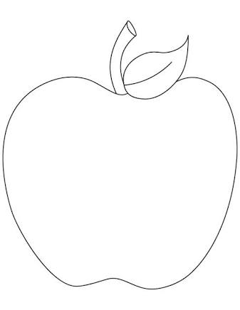
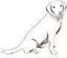
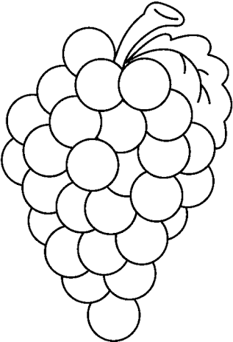

_______________ ________________ __________________

THE END

